**Concatenate**

**Yeah, big word.**

All it really means is **combine** text (remember, text is called a string) and variables together into single sentences! 😲🤯

You can make your input and output look super pretty now! 🥳

👉 Copy the code below into main.py and run it. See what it does:

myName = input("What's your name? ")

myLunch = input("What are you having for lunch? ")

print(myName, "is going to be chowing down on", myLunch, "very soon!")

You just made a full sentence, right? But how did it work?

* It turns out print has a super-power. We can give it as **many** different things to print as we want. All we need to do is put a comma , between every different thing in the ().

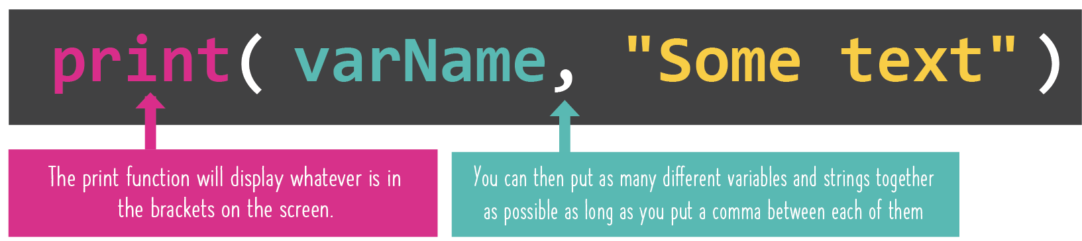

👉 Let's go BIG and try a bunch of code... *You probably know this by now, but make sure you delete any old code first and add all code to main.py.*

number = input("Give me a number: ")

group = input("Give me a collective noun for a group of things: ")

thing = input("Give me the name of a weird or wacky thing: ")

print("No I don't think that", number, "is a", group, "of", thing,". That's just odd.")

**You can combine as many things as you want in any order you want, as long as they're separated by that comma!**